|  |  |
| --- | --- |
| **NAME** | **ABIS RAZA HAIDER** |
| **REGISTRATION NUMBER** | **SP24-BSE-145** |
| **ASSIGNMENT** | **3** |
| **SUBMITTED TO** | **SIR SHAHID BHATTI** |



**I created a data entry form using GUI FX.**

**Now I show you my form.**

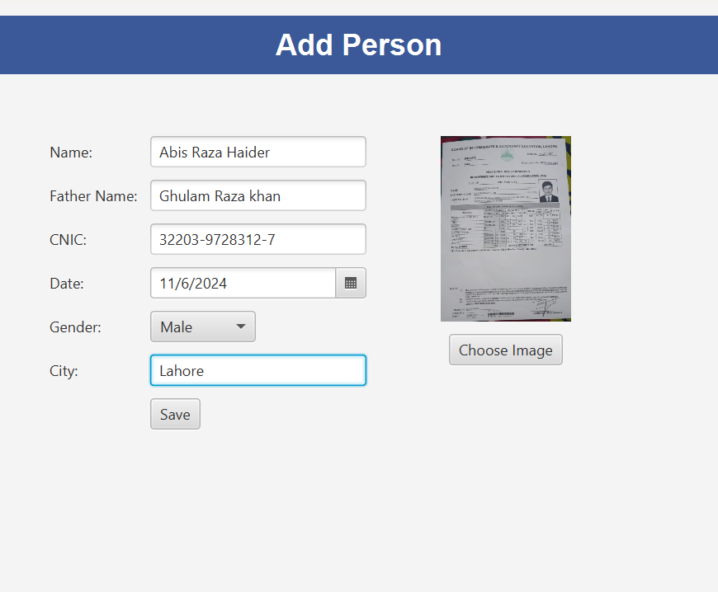

**As You can see, I have added all the necessary information required to create a form.**

**I have added person’s name, Father’s name, CNIC, Date of birth, Gender, City and the image of the person.**

**After clicking the save button, a message is shown which is given below:**

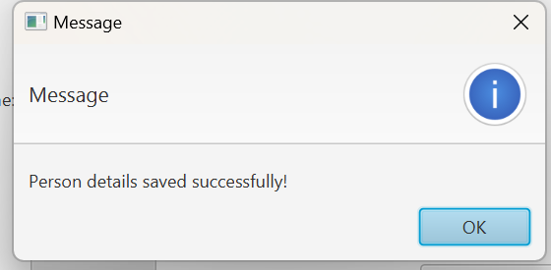

**So that’s all from the form I have created**

**THANK YOU!**